**Introducing The Rockart Center**

The Rockart Center is a unique collective of business and IT strategists, seeking to ‘raise the game’ in Business / IT Alignment and the practice of Enterprise Architecture. The [Rockart Center](http://www.rockart.center/) is named after John F. Rockart – a pioneer of Enterprise Architecture from the MIT Sloan School of Management who first invented the concept of Business / IT Alignment.

Our highly qualified and experienced technology professionals bring a wealth of pragmatic methodology and practical experience to our clients. Our team has, on average, over 20 years’ individual professional experience in Enterprise Architecture.

Our professionals are framework and tool agnostic thereby delivering the best client outcomes, and providing on-going support if required. We have full coverage of all the EA disciplines (Business Architecture, Information Architecture, Application and Technology Architecture), Solution architecture and the ability to integrate these into program and project management systems.

We’re been dissatisfied with the traditional mode of delivery: consult, deliver, and leave, only for the work to be re-done by the same or a different consultancy a year or two later. We propose a sustainable approach: **Engage, Consult, Deliver and Nurture**. The ‘nurture’ can be anything on the sliding scale of fully outsourced management of how the enterprise works (from business services to servers) through to training up the local staff and keeping in touch on an ongoing basis. The latter goes far beyond the usual “send them on [insert framework here] course and they’ll be fine”; we don’t just implement nor train using base frameworks. We train in how to apply those frameworks in the real world, and to enable one thing: useful business knowledge and IT investment decision making, and hence benefit.

We have established strong linkages to local Universities and their post-graduate information systems and Enterprise Architecture programs; indeed a number of us are adjunct lecturers in Enterprise Architecture and Information Systems. While we have active engagement in research, Rockart is founded on a pragmatic practice-based approach to consulting and project delivery. We are working with leading academics to develop the first genuine practice-based education and industry certification program for Enterprise Architects (the Certified Practicing Enterprise Architect) – which will be like a CPA for IT.

**Our Services** are based on the role Architecture (and Architectural Governance) plays in supporting our service lifecycle, from Analysis through to Operations and in also Informing and Educating our clients and fellow practitioners on research and emerging architectural trends, tools and techniques.

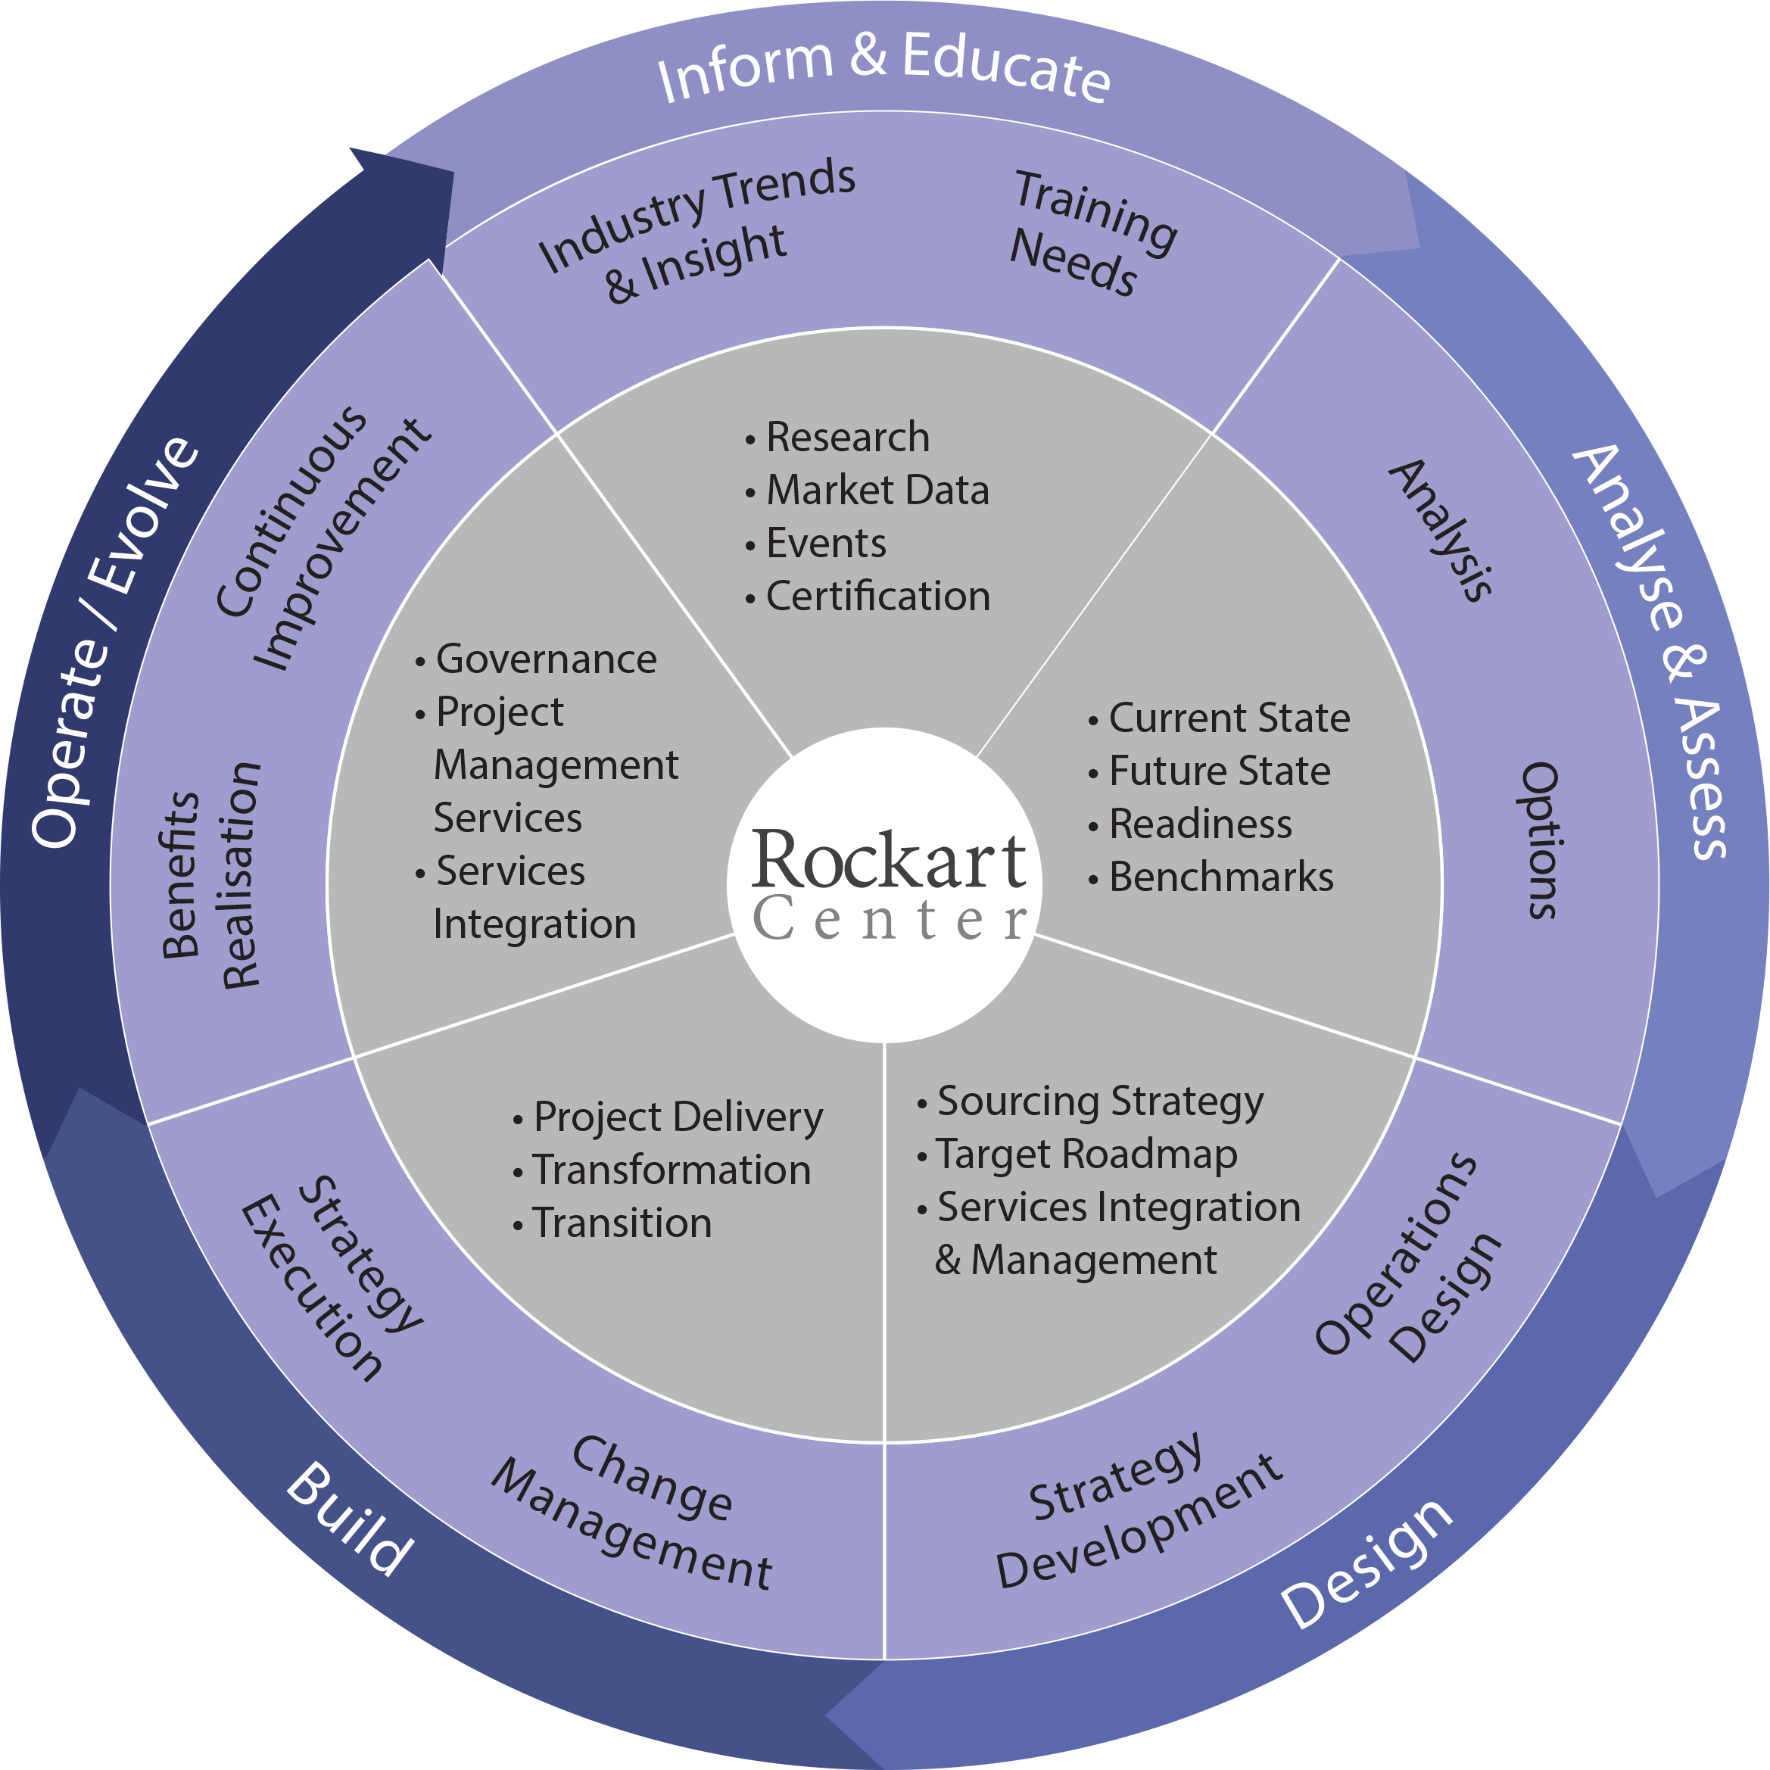

The services delivery framework is applied across our domains expertise and core focus areas such as cloud computing, business intelligence, digital channel strategy and enterprise integration, recognising that success is in the business leveraging technology to deliver an outcome.

We offer flexibility in how we deliver our service from “EA as a service”, project based services, or in line Enterprise and Information Architecture and Solution Architecture roles.

**Our Consultants** have strong associations with each other and their peers through our working careers and share the same values promoted by Rockart. We have particular experience in the Financial, Government, Community, Manufacturing, Education and Utilities sectors.

Our site, [www.Rockart.Center](http://www.Rockart.Center) provides more detail on our consultants.

**Enterprise Architects**

**John Radford**

* Expert in implementing Enterprise Architecture tools and methodologies
* Significant experience as an Enterprise Architect and IT strategist;
* Background in enterprise integration and SOA, with experience in integrating trusted and semi-trusted environments (B2B trading partners, etc);

**Shane Mortensen**

* Breadth of experience as a hands-on, delivery focussed Enterprise Architect and IT strategist – ideal for this engagement;
* Experience in assessing, planning and implementing Data Centre, Cloud, *aaS, Hybrid and distributed operations;
* Experience in building and leading teams in complex and multi-faceted programmes with competing priorities and multiple concurrent deliverables;

**Tony Ketteringham**

* Extensive experience at multiple levels of Architecture: including Enterprise, Solution, Software, Design and Implementation;
* Cloud Auditing based on Assessments Initiative Questionnaire (CAIQ) v3.0.1 developed by the Cloud Security Alliance;

**Dr Kim Elms**

* Expertise in Enterprise Architecture and Solution Architecture, involving technology platforms, applications and integration methods;
* Recent experience delivering outsourcing frameworks resulting in cloud and specialised vendor transition, delivery and frameworks for future management;
* In 2014 completed a deep study around cloud and secure hosting models;
* Business analysis around sustainable cloud computing architectures;

**Duncan Unwin**

* Enterprise Architecture expertise in the government and commercial sectors;
* Expertise in partner outsourcing models – cloud and vendor;
* In-depth understanding of cloud business and technical models, including managing the migration to Cloud and internal IT business model transformation
* Expert in Information Governance & ISO 27001 certified auditor
* Industry knowledge of Banking & Finance, Health, Manufacturing

**Graham Richards**

* Expert in integrating EA into Program management / PMO
* Enterprise Architecture expertise in the government and commercial sectors;
* Expertise in business case development